Q1. Explain Polymorphism in java programming?

Ans: Poly morphism means one name many forms

Examples of Polymorphism

MySelf for You as a Trainer

Myself for Student in college as a Professor

Myself for Home I am son

Myself for My child I am Father

Myself for Wife I am Husband

Myself for Parents I am son

Types of Polymorphism

1. Compile time Polymorphism

Method Overloading

1. Run Time Polymorphism

Method Overriding

Q2. Explain Method overloading in Java programming?

Ans:

Method Overloading means having two or more methods in a class with the same name and different types of Parameters or different number of Parameters.

Syntax:

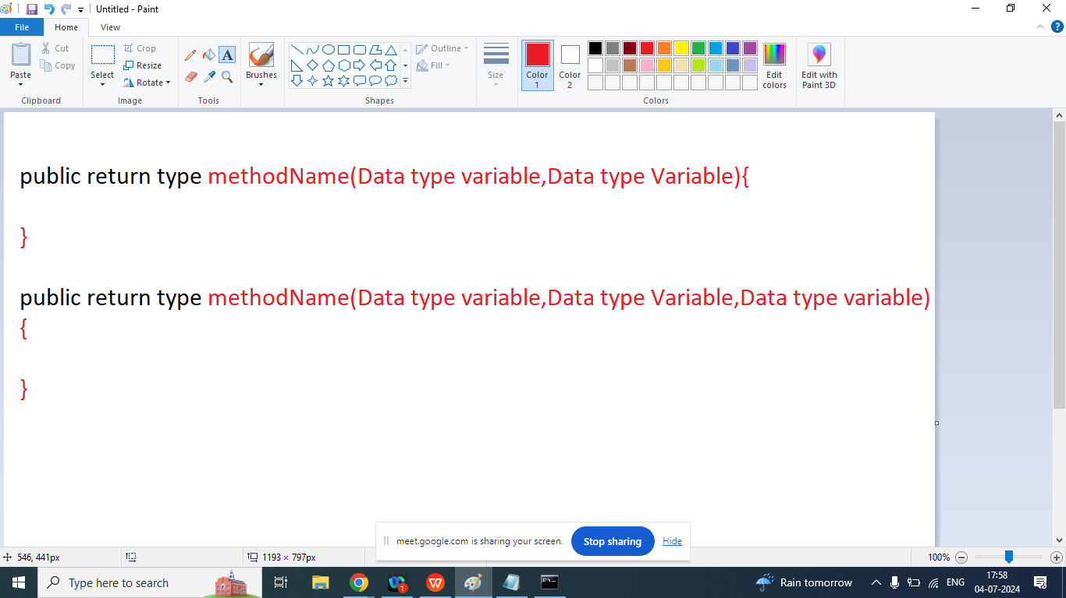

class Op1{

public void add(){

int a,b,c;

a=10;

b=20;

c=a+b;

System.out.println("Addition without argument"+c);

}

public int add(int a,int b){

int c;

a=10;

b=20;

c=a+b;

System.out.println("Addition with two int argument"+c);

return c;

}

public void add(float a,float b){

float c=a+b;

System.out.println("Add two float : "+c);

}

public void add(double a,double b){

double c=a+b;

System.out.println("Add two double : "+c);

}

public void add(String a,String b){

int c=Integer.parseInt(a)+Integer.parseInt(b);

System.out.println("Add two String : "+c);

}

public static void main(String args[]){

Op1 obj=new Op1();

obj.add();

obj.add(5,7);

obj.add(12.5,2.5);

obj.add(2.5f,2.5f);

obj.add("1","1");

}

}

Q2. Explain Method overriding in java programming?

Ans: In java method overriding is a features that allows a sub class or child class to provide a specific implementation of a method that is already defined in Parent class. When a method in a sub class has the same name, same return type, same argument (type)

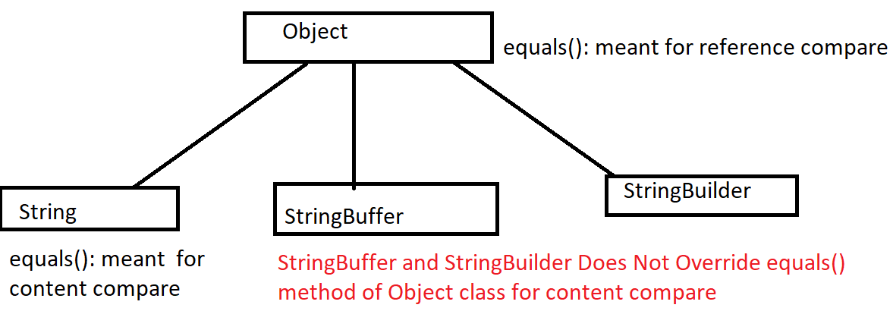

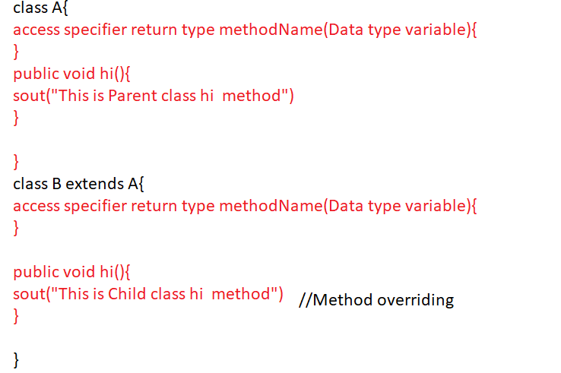

class A{

public void hi(){

System.out.println("This is Parent class hi... method()");

}

}

class B extends A{

public void hi(){

System.out.println("This is Child class hi... method()");

}

public static void main(String args[]){

A obj=new B();

obj.hi();

}

}